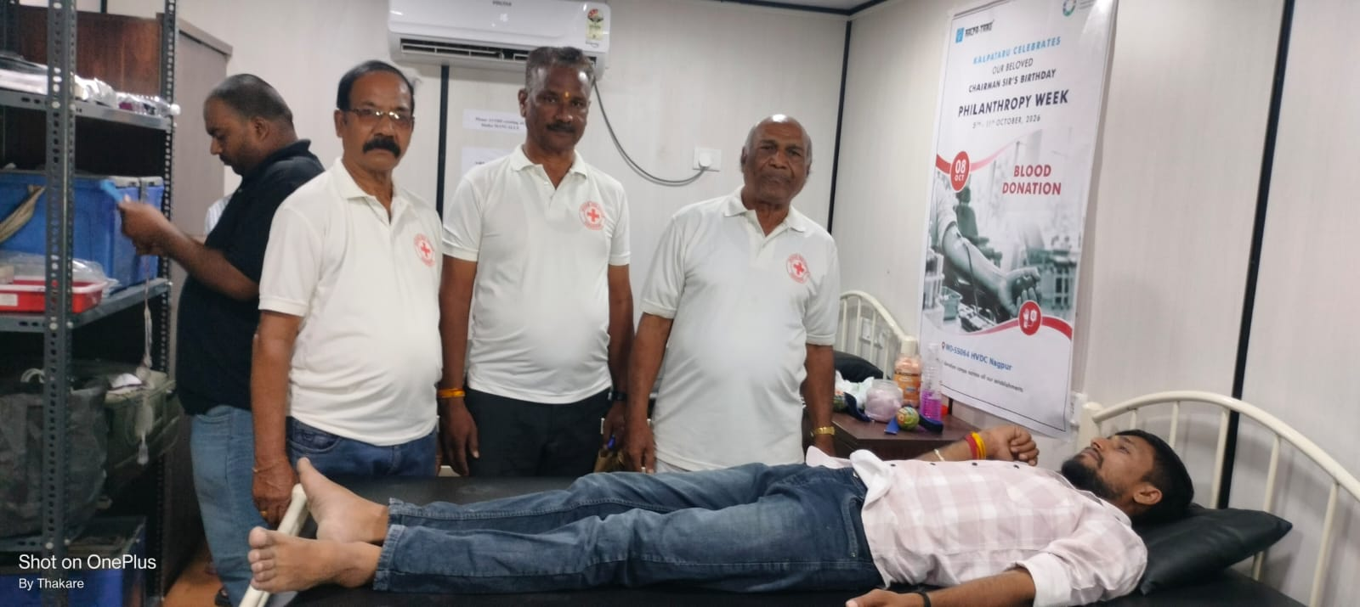
On 7th October 2026 the Indian Red Cross Society, Wardha District Branch, in collaboration with General Hospital, Wardha, organized a Blood Donation Camp at Kalptaru Projects, Bhosa, Samadrapur, Dist Wardha. Total 27 units collected. Office bearers of the Wardha Red Cross, doctors from General Hospital, Wardha, and dignitaries from Kalptaru Projects were present on the occasion.

